User Manual v1.2
How to install 3
How to play 4
Publish settings 5
Setup buddle id 5
Setup chartboost id 5
set up your buddle id 5
Setup in-app purchanse 6
Other setup 6
New level settings 8
Setup total level number 8
Setup level score 8
Setup level tips 8
Games Interactive Examples 9
Simple Touch 10
Simple Drag 11
Mutiple tap 12
Detect holding on screen 13
Eraser effect 14
Pinch & pan 15
Detect Swipe 16
Detect shake 17
Dectect gravity 18
Dectect gravity 18
Detect Collision & Trigger 19
Localizations 20
Read localization string 20
Detect your language 21
Basic skills you must know 23
build and submit a game on app store with unity. 23
How to Set up a chartboost id 23
Author support 24

How to install
- Create a new project and import the assets.
- The game already set up with the default android platform.
- Find windows->Services from Unity menu.
Make sure In-app purchanse is turned on.
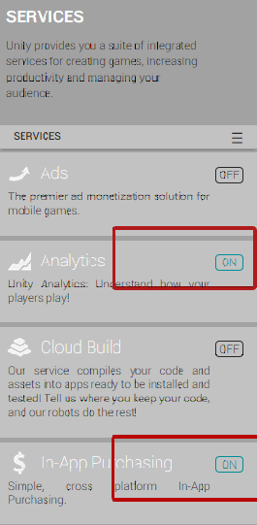
- Start the game with startScene scene

How to play
This game contains 21 different levels.
The main purpose of the game is try to get the bread and not let it be be destroyed,be took by other or droped.
You can read tip for each level or skip for the level.
Each tip cost 20 coins and 60 for skip.
Coins can be bought from store.
After level 3,each time you win or lose.There would be a certain chance to show interstitial ads.

Publish settings

Setup buddle id
Each game must have a different Bundle id. So you must made the id to fit the id you request from your apple.
From File->build setting,open the build setting panel. Find and click player setting button.
On inspector panel,Click other settings panel.Change buddle id in bundle identifier section.

Setup chartboost id
Find on unity editor from Chartboost->edit setting.
On the inspector panel on right. You should find where to setting up the chartboost id.

set up your buddle id
Each game must have a different Bundle id. So you must made the id to fit the id you request from your apple.
File->build setting,open the build setting panel. Find and click player setting button.
On right inspector panel,touch other settings panels.Change buddle id on bundle identifier section.

Setup in-app purchanse
First you need to active the unity serverice(Window->services) and turn the iap service on.
You need to setup product id if you decide publish to any store. Open Gamemanager.cs the script and find:
public const string CONSUMABLE0 = "td15612.coin1";
public const string CONSUMABLE1 = "td15612.coin2";
public const string CONSUMABLE2 = "td15612.coin3";
public const string CONSUMABLE3 = "td15612.coin4";
The orange words are the values you must change to fit the id you required from your appstore or goolgeplay developer website.
Iap always return true by test mode.
To disable it,find public bool test = true;
And set it to public bool test = false;

Other setup
In const.cs Pay attention for LEADER_BOARD_ID,appid.
These 2 relative your gamecenter id and your game app id.
panelMain.cs
Search and found
Application.OpenURL ("http://itunes.apple.com/WebObjects/MZSearch.woa/wa/search?submit=seeAllLockups&media=software&entity=software&term=xxxxxx");
Change the url you need to be a more games link.

New level settings

Setup total level number
Search GameData.cs and open it.
Find public static int totalLevel = 21;
Change number 21 to how many levels you’ve made for this game.

Setup level score
In GameData.cs Find like
case "level21":
tbestScore = 10;
break;
This parameter bestScoreBase means,if you finish level 21 in 10 seconds.You would get 3 star.So play your game and try to give it a proper number.

Setup level tips
This game got a level tip system.Find under ../resource/localizations/
There are txt file for localization
If you are using English And wanna give level 22 a level tip,just add
level22tip = xxxx
xxx is your level tip context.
See detail on Localization part of the manual

Games Interactive Examples
This game framework support a lot of input types for interactive.Here I list the most common interactives with a real minigame example. After taking a look of these examples. You would be able to make your own mini puzzles very easily.

Simple Touch
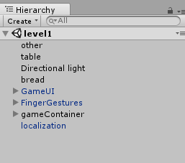
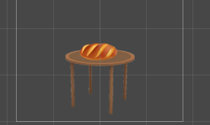
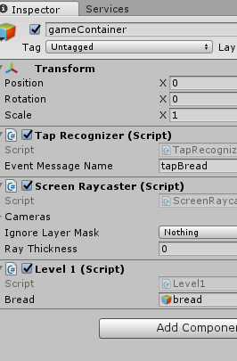
Open level1 scene file,see its inspector in hierarchy and gameObjects on Scene window.
This level we touch the bread,pick it up.
Then we win the level.We create public variables for gameobject which needs to be controlled and assign all of them.
There is only one interactive object of the game called bread. We assigned it in level1.cs.We must attach Taprecognizer script to make the game be able to receive tap inputs,and we create a function named tapBread to receive tap event.
public GameObject bread;//the instance of the object used in game.
void tapBread( TapGesture gesture )
{
if (GameData.getInstance ().isLock)//If the game locked,you can not control the game.
return;
if(gesture!=null && gesture.Selection == bread )//if taped the bread
{
Destroy (bread);//remove the bread
GameData.getInstance ().main.gameWin (); //tell the engine the game wins.
}
}
Level1.cs

Simple Drag
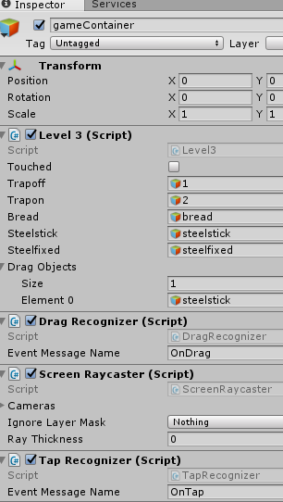
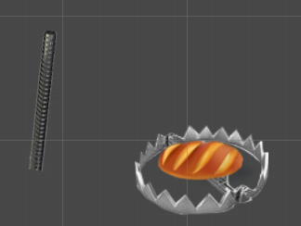
Open level3 scene file, select gameContainer gameobject in hierarchy and look into the inspector panel.
Same as level1,we create a new script name level3 and create all variables of objects on board and assigned all of them.
This Level we needs both drag and tap interactives.So we both attach drag recognizer and tap recognizer.
Open level3.csWe will see there is a function called OnDrag.See detail comments in level3.cs of how to deal with drag events.

Mutiple tap
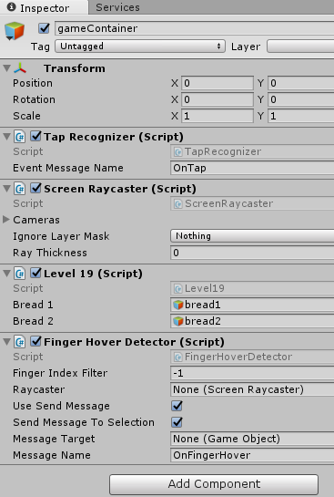
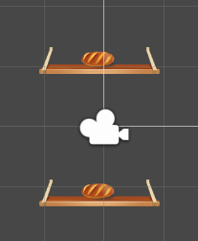
Open level19 scene file, select gameContainer gameobject in hierarchy and look into the inspector panel.
We assigned all the interactiveable objects to the level19.cs script.
This level we attached a fingerHoverDetector.cs and detect every finger touch on screen in onFingerHover function.
See detail comments in level19.cs about how to deal with more than 1 tap.

void OnFingerHover( FingerHoverEvent e )
{
if (GameData.getInstance ().isLock)
return;
if( e.Selection == bread1 )
{ //deal with the event while bread1 was touched

if( e.Selection == bread2 )
{ //deal with the event while bread2 was touched
level19.cs

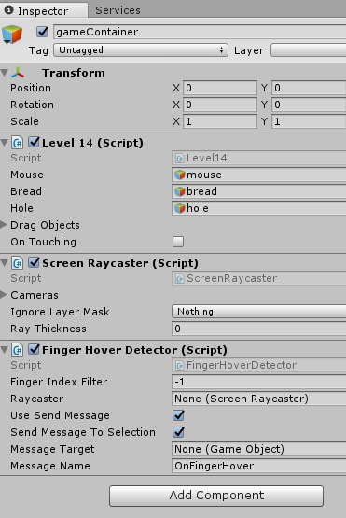
Detect holding on screen
Mouse is hide here
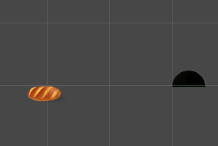
This level,when your finger holding on the bread,the mouse wont see it and after several seconds,it moves away and you will win the level.
See detailed commets in level14.cs OnFingerHover function.

void OnFingerHover( FingerHoverEvent e )
{
if (GameData.getInstance ().isLock)//if locked,ignore all customer interactive
return;
if( e.Selection == bread )//if target is bread
{
// finger entered the object
if( e.Phase == FingerHoverPhase.Enter )//start touch
{
onTouching = true;//whether touching flag
}
else if( e.Phase == FingerHoverPhase.Exit ) // finger left the object
{
onTouching = false;//whether touching flag
}
level14.cs
}
}

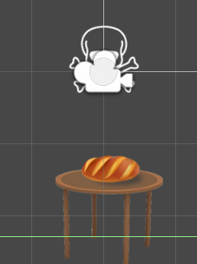
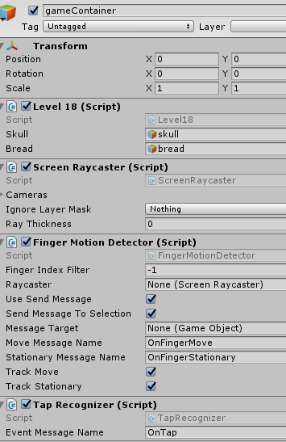
Eraser effect
Erase area
This level we simulate an eraser effect. By moving constantly on the skull ,it will slowly became transparent then disappear.
We use fingerMotionDetector to detect mouse/finger moving and tapRecognizer to detect tap on bread. See detailed commets in level18.cs OnFingerMove function.
void OnFingerMove( FingerMotionEvent e )
{
if (e.Selection == skull) {//is touching on skull target
if (e.Phase == FingerMotionPhase.Started) {//is start moving
} else if (e.Phase == FingerMotionPhase.Updated) {//is moving
myalpha = sp.color.a - .004f;//keep decrease the skull alpha
sp.color = new Color (sp.color.r, sp.color.g, sp.color.b, myalpha);//update color
if (myalpha <= 0) {
sp.enabled = false;//keep alpha to zero if
}
} else {
level18.cs

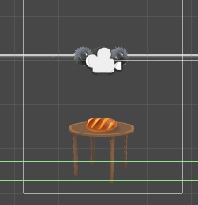
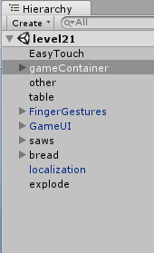
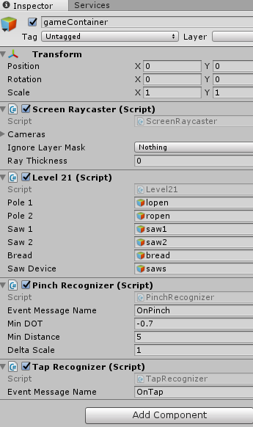
Pinch & pan

This level, we can use pin/pan gesture to control game objects. Use mouse wheels to simulate the effect while test on a pc.
We need pinchRecognizer to detect pin/pan interatcives.
See detailed commets in level21.cs OnPinch function.
void OnPinch( PinchGesture gesture )
{
if( gesture.Phase == ContinuousGesturePhase.Started )
{
Pinching = true;//start pinch
}
else if( gesture.Phase == ContinuousGesturePhase.Updated )
{
if( Pinching )
{
//moving the poles and saws by time delta while pinch or pan
pole1.transform.position+= new Vector3(-Mathf.Sign(gesture.Delta)*.1f,0,0);
pole2.transform.position+= new Vector3(Mathf.Sign(gesture.Delta)*.1f,0,0);
level21.cs

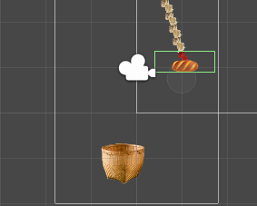
Detect Swipe
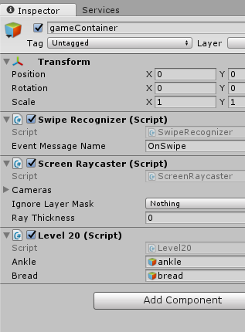
The green frame showes the swipe area,you do a swipe gesture within this area and the swipe event triggers.
We attached the SwipeRecognizer script
To detect the swipe gesture
See detailed commets in level20.cs OnSwipe function.

void OnSwipe( SwipeGesture gesture )
{
// make sure we started the swipe gesture on our swipe object
GameObject selection = gesture.StartSelection; // we use the object the swipe started on, instead of the current one
if( selection == ankle )//start in the swipe area
{
level20.cs

Detect shake
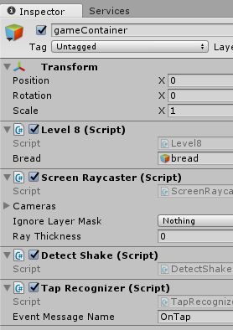
In level8,there is nothing on the screen.
So Where can I to find the bread.
The trick is just shaking your device.
What we only need is just attach the DetectShake.cs script and deal with shake events in a function named shake.
See detailed in level8.cs shake function.


void shake(){
//shake screen effect
ATween.ShakePosition(Camera.main.transform.gameObject,
ATween.Hash("x",1, "time", 1, "delay",0,"easetype", ATween.EaseType.easeInOutQuint));
//active the hidden bread's physical and drop it off
bread.GetComponent<Rigidbody>().isKinematic = false;
bread.GetComponent<Rigidbody>().AddForce(Vector3.down);
}

level8.cs

Dectect gravity
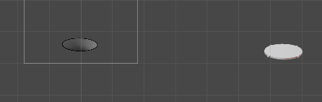
In level16
We control the manhole cover by tilting the device.
To realize such function,there is no extra scripts required.
Just see detailed scipts and commets in level16.cs.
void Update () {
//if (!GameData.getInstance ().startgame)
//return;
Vector3 dir = Vector3.zero;
// we assume that device is held parallel to the ground
// and Home button is in the right hand
// remap device acceleration axis to game coordinates:
// 1) XY plane of the device is mapped onto XZ plane
// 2) rotated 90 degrees around Y axis
dir.x = Input.acceleration.x;
if(Mathf.Abs(dir.x)<=.1f)return;
// dir.z = Input.acceleration.x;
// clamp acceleration vector to unit sphere
if (dir.sqrMagnitude > 1)
dir.Normalize();
// Make it move 10 meters per second instead of 10 meters per frame...
dir *= Time.deltaTime;
// Move object by gravity
holeCover.transform.Translate (new Vector3(dir.x * speed,0,0));
}

level6.cs

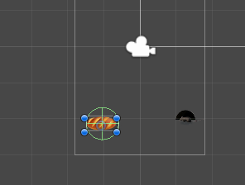
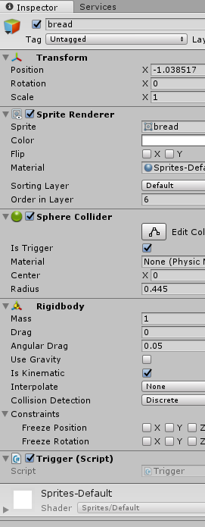
Detect Collision & Trigger
Open level2
In this level,when the mouse touch the bread,it will hold and pushing the bread.Then you lose the game.So we need to detect when the mouse touch the bread.Due to this,we need a trigger to detect this the collision.
We attached the trigger.cs script to bread gameobject.
All the collision detection can be dealed within trigger.cs and classify by levelname

void OnTriggerEnter(Collider collider){
switch(SceneManager.GetActiveScene().name){
case "level2":
if (collider.name == "mouse") {
g.SendMessage ("mouseHitBread");
}
break;
case "level4":

Trigger.cs

Localizations

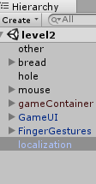
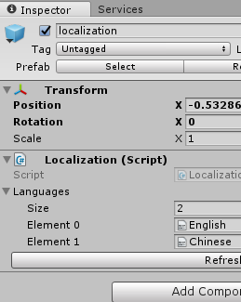
Read localization string

Each level we attached a prefab named localization
We attach localization text file in its inspector panel.
Open English.txt
In the file,each line refer to a phase which needs to be localized
Like phaseName = phaseContext
For example: levelname21 = level 21
In game,you do the localization by
xxx.text = Localization.Instance.GetString ("levelname21");

Detect your language
public int GetSystemLaguage(){
int returnValue = 0;
switch (Application.systemLanguage) {
case SystemLanguage.Chinese:
returnValue = 1;
break;
case SystemLanguage.ChineseSimplified:
returnValue = 1;
break;
case SystemLanguage.ChineseTraditional:
returnValue = 1;
break;
default:
returnValue = 0;
break;
}
returnValue = 0;//test
return returnValue;
}

gameData.cs

In GameData.cs,we see a function call GetSystemLanguage.
This function get system language by switch branches.
You should add the language cases only when your localization file(txt) is ready.Otherwise if the system did not find the right translation file,it would throw errors.
For default testing
returnValue = 0;//test
This line is uncommented. The language will always be English .If you may not have time to deal with your own native translation or you did not want a localization function for your game,just leave it uncommented.

Basic skills you must know

build and submit a game on app store with unity.
https://www.youtube.com/watch?v=C3izqF6h_aY

How to Set up a chartboost id
https://answers.chartboost.com/hc/en-us/articles/201219435-iOS-SDK-Download

Author support
Contact to us
E-mail

If you want support our work or feel interested in other assets, take a look at
More Games

